In JavaScript, `window`, `screen`, and `document` are three different objects that provide access to various properties and methods related to the web page and the browser. Here's a brief overview of the differences between them:

1. `window` Object:

- The `window` object represents the browser window or the global JavaScript context in a web page.

- It is the top-level object and serves as the global context for JavaScript execution in a web page.

- It provides access to various properties and methods related to the browser window, including things like `alert()`, `setTimeout()`, and `localStorage`.

- Global variables and functions declared in JavaScript are automatically attached to the `window` object.

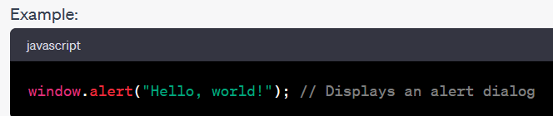

2. `screen` Object:

- The `screen` object provides information about the user's screen or monitor.

- It includes properties such as `screen.width`, `screen.height`, and `screen.availWidth`, which give information about the screen's dimensions and available space.

- It is useful for tasks like determining the screen size for responsive design.

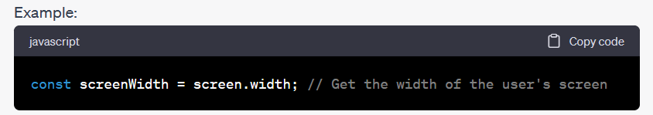

3. `document` Object:

- The `document` object represents the web page itself and provides access to the HTML content and structure of the page.

- It allows you to manipulate the DOM (Document Object Model) and interact with the elements on the page.

- You can use methods like `document.getElementById()`, `document.querySelector()`, and properties like `document.title` to interact with and modify the web page.

Ex :

const pageTitle = document.title; // Get the title of the web page

const headerElement = document.getElementById("header"); // Get an element by its ID

In summary, while `window` is the top-level object representing the browser window and global context, `screen` provides information about the user's screen, and `document` represents the web page's structure and content, allowing for DOM manipulation. These objects serve different purposes and provide access to different aspects of web development within the context of a web page.